# Question Set 04

### Critical Radius of insulation

1. Consider the situation where there is a tube of 0.003m outside radius (designated r1) and 1m length. It is exposed to still air such that the convective heat transfer coefficient h is 5 W/(m2.K). It is proposed to insulate the tube with flexible urethane foam for which the conductivity k is 0.036 W/(m.K). Various thicknesses of insulation are being considered which will result in the outer cylindrical radius (designated r2) varying from 0.003m (bare tube) to 0.027m in 0.003m increments. Draw up a table with 4 columns. The first column is outside radius r2 in metres, the second is conductive resistance of the insulation Rins in K/W, the third is convective resistance of the outer surface Rconv in K/W, the fourth is combined conductive and convective resistance **(**Rins + Rconv**)** in K/W. Observe how the various resistances vary as the outer radius is changed.
2. For the situation described in 4.1 calculate (i) the critical radius (ii) the combined conductive and convective resistance **(**Rins + Rconv**)** for 1 m of tube when r2 reaches the value of critical radius. ***Answer****: (i) 0.0072m, (ii) 8.29 K /W*
3. Consider an insulated pipe exposed to the atmosphere. Will the critical radius of insulation be greater on calm days or on windy days? Why?

### Fins

1. What is the difference between the fin effectiveness and the fin efficiency?
2. Two finned surfaces are identical, except that the convection heat transfer coefficient of one of them is twice that of the other. For which finned surface will the (*a*) fin effectiveness and (*b*) fin efficiency be higher?
3. Hot water is to be cooled as it flows through the tubes exposed to atmospheric air. Fins are to be attached in order to enhance heat transfer. Would you recommend attaching the fins inside or outside the tubes? Why?
4. Does the (*a*) efficiency and (*b*) effectiveness of a fin increase or decrease as the fin length is increased?

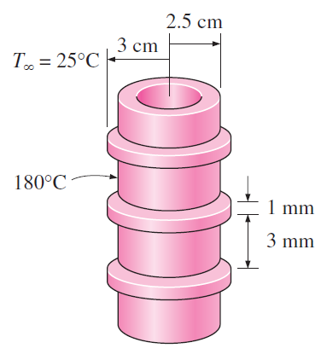

1. Steam in a heating system flows through tubes whose outer diameter is 5 cm and whose walls are maintained at a temperature of 180°C. Circular aluminium alloy 2024-T6 fins (*k* =186 W/m · °C) of outer diameter 6 cm and constant thickness 1 mm are attached to the tube. The space between the fins is 3 mm, and thus there are 250 fins per meter length of the tube. Heat is transferred to the surrounding air at *T∞ =* 25°C, with a heat transfer coefficient of 40 W/m2 °C. Determine the increase in heat transfer from the tube per meter of its length as a result of adding fins. *Answer:* 2639 W
2. A 0.3-cm-thick, 12-cm-high, and 18-cm-long circuit board houses 80 closely spaced logic chips on one side, each dissipating 0.04 W. The board is impregnated with copper fillings and has an effective thermal conductivity of 20 W/m·°C. All the heat generated in the chips is conducted across the circuit board and is dissipated from the back side of the board to a medium at 40°C, with a heat transfer coefficient of 50W/m2·°C. (*a*) Determine the temperatures on the two sides of the circuit board. (*b*) Now a 0.2-cm-thick, 12-cm-high, and 18-cm-long aluminum plate (*k =* 237 W/m·°C) with 864 2-cm-long aluminum pin fins of diameter 0.25 cm is attached to the back side of the circuit board with a 0.02-cm-thick epoxy adhesive (*k =*1.8 W/m·°C). Determine the new temperatures on the two sides of the circuit board.

2 cm

1. Watch the following video to understand how fins are constructed for heat transfer

*https://www.dlsweb.rmit.edu.au/set/Videos/MIET2081/AC-Finconstruction.mp4*

### Numerical Conduction

1. Consider a medium in which the finite difference formulation of a general interior node is given in its simplest form as



(*a*) Is heat transfer in this medium steady or transient?

(*b*) Is heat transfer one-, two-, or three-dimensional?

(*c*) Is there heat generation in the medium?

(*d*) Is the nodal spacing constant or variable?

(*e*) Is the thermal conductivity of the medium constant or variable?

30°C

Δ*x*

No heat generation

•

•

•

•

•

•

800 W/m2

•

•

•

0 1 2 3 4 5 6 7 8

1. Consider steady one-dimensional heat conduction in a plane wall with variable heat generation and variable thermal conductivity. The nodal network of the medium consists of nodes 0, 1, and 2 with a uniform nodal spacing of ∆*x.* Using the energy balance approach, obtain the finite difference formulation of this problem for the case of specified heat flux *q*0 to the wall and convection at the left boundary (node 0) with a convection coefficient of *h* and ambient temperature of *T*∞, and radiation at the right boundary (node 2) with an emissivity of and surrounding surface temperature of *T*surr.
2. 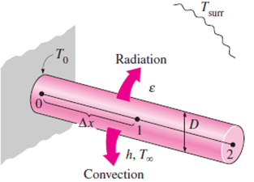Consider steady one-dimensional heat conduction in a pin fin of constant diameter *D* with constant thermal conductivity. The fin is losing heat by convection to the ambient air at *T*∞ with a convection coefficient of *h*, and by radiation to the surrounding surfaces at an average temperature of *T*surr. The nodal network of the fin consists of nodes 0 (at the base), 1 (in the middle), and 2 (at the fin tip) with a uniform nodal spacing of ∆*x.* Using the energy balance approach, obtain the finite difference formulation of this problem to determine *T*1 and *T*2 for the case of specified temperature at the fin base and negligible heat transfer at the fin tip. All temperatures are in °C.
3. 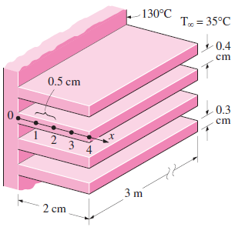One side of a 2-m-high and 3-m-wide vertical plate at 130°C is to be cooled by attaching aluminum fins (*k* = 237 W/m · °C) of rectangular profile in an environment at 35°C. The fins are 2 cm long, 0.3cm thick, and 0.4 cm apart. The heat transfer coefficient between the fins and the surrounding air for combined convection and radiation is estimated to be 30 W/m2°C. Assuming steady one-dimensional heat transfer along the fin and taking the nodal spacing to be 0.5 cm, determine (*a*) the finite difference formulation of this problem, (*b*) the nodal temperatures along the fin by solving these equations, (*c*) the rate of heat transfer from a single fin, and (*d*) the rate of heat transfer from the entire finned surface of the plate.
4. Consider a medium in which the finite difference formulation of a general interior node is given in its simplest form as



(*a*) Is heat transfer in this medium steady or transient?

(*b*) Is heat transfer one-, two-, or three-dimensional?

(*c*) Is there heat generation in the medium?

(*d*) Is the nodal spacing constant or variable?

(*e*) Is the thermal conductivity of the medium constant or variable?

1. Consider steady two-dimensional heat transfer in a long solid body whose cross section is given in the figure. The measured temperatures at selected points of the outer surfaces are as shown. The thermal conductivity of the body is *k* = 45 W/m · °C, and there is no heat generation. Using the finite difference method with a mesh size of ∆*x =* ∆*y =* 2.0 cm, determine the temperatures at the indicated points in the medium. *Hint:* Take advantage of symmetry.

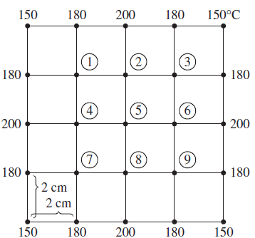

1. How does the finite difference formulation of a transient heat conduction problem differ from that of a steady heat conduction problem? What does the term р*A*Δ*xC $\left(T_{m}^{i+1}-T_{m}^{i}\right)$/* Δ*t* represent in the transient finite difference formulation?
2. What are the two basic methods of solution of transient problems based on finite differencing? How do heat transfer terms in the energy balance formulation differ in the two methods?
3. Consider transient one-dimensional heat conduction in a plane wall that is to be solved by the explicit method. If both sides of the wall are subjected to specified heat flux, express the stability criterion for this problem in its simplest form.
4. Consider transient one-dimensional heat conduction in a pin fin of constant diameter *D* with constant thermal conductivity. The fin is losing heat by convection to the ambient air at *T*∞ with a heat transfer coefficient of *h* and by radiation to the surrounding surfaces at an average temperature of *T*surr. The nodal network of the fin consists of nodes 0 (at the base), 1 (in the middle), and 2 (at the fin tip) with a uniform nodal spacing of Δ*x.* Using the energy balance approach, obtain the explicit finite difference formulation of this problem for the case of a specified temperature at the fin base and negligible heat transfer at the fin tip.
5. A hot surface at 120°C is to be cooled by attaching 8 cm long, 0.8 cm in diameter aluminum pin fins (*k =* 237W/m°C and $α=$ 97.1 x 10-6 m2/s) to it with a center-to-centerdistance of 1.6 cm. The temperature of the surrounding medium is 15°C, and the heat transfer coefficient on the surfaces is 35 W/m2 · °C. Initially, the fins are at a uniform temperature of 30°C, and at time *t* = 0, the temperature of the hot surface is raised to 120°C. Assuming one-dimensional heat conduction along the fin and taking the nodal spacing to be Δ*x =* 2 cm and a time step of Δ*t =* 0.5 s, determine the nodal temperatures after 5 min by using the explicit finite difference method. Also, determine how long it will take for steady conditions to be reached.

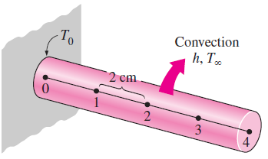

## Equations:

**Critical Radius of Insulation**

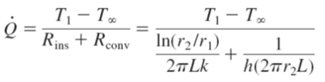

**Fins**

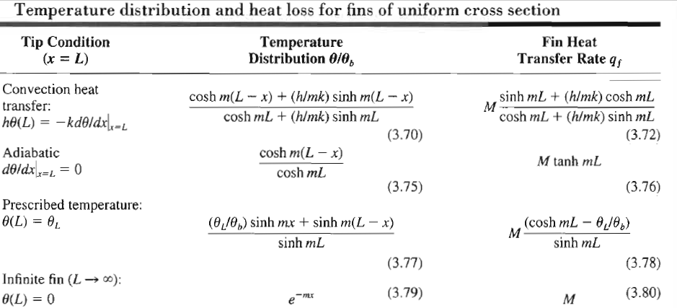

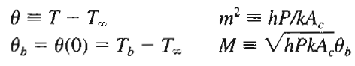

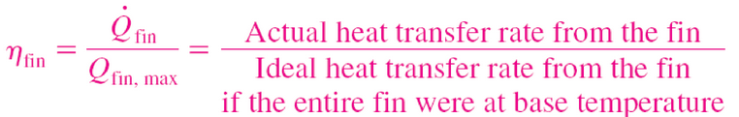

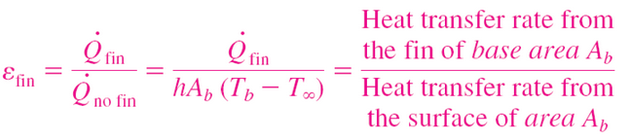

* Additional equations/charts you may need can be found on the lecture slides